**Linux Commands practice :**

**1. Type following command in your directory.**

ls

ls –a

ls –la

ls -Fa

• ls: Lists the files and directories in the current directory.

• ls -a: Lists all files and directories, including hidden ones (those starting with a dot).

• ls -la: Lists all files and directories, including hidden ones, in long format, showing detailed information like permissions, number of links, owner, group, size, and modification date.

• ls -Fa: Lists all files and directories, including hidden ones, and adds a trailing / for directories, * for executables, and @ for symbolic links.

1 . ls :

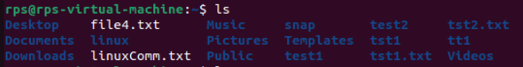

2. ls –a :

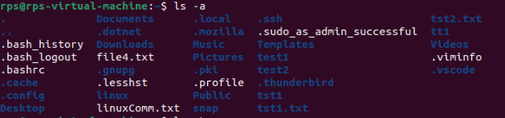

3. ls –La:

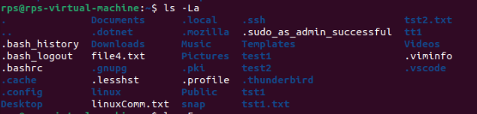

4. ls –Fa:

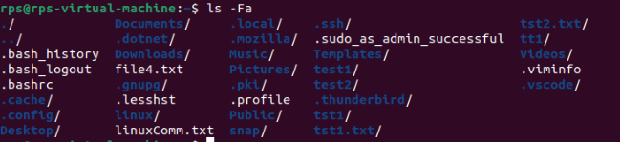

**2. Make a directory**

mkdir linux

pwd

cd linux

pwd

cd

pwd

rmdir linux

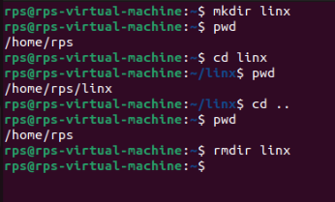

**Commands** **ls** : show files in current position **cd** : change directory **cp** : copy file or directory **mv** : move file or directory **rm** : remove file or directory **pwd** : show current position **mkdir** : create directory **rmdir** : remove directory **less, more, cat** : display file contents **man** : display online manual

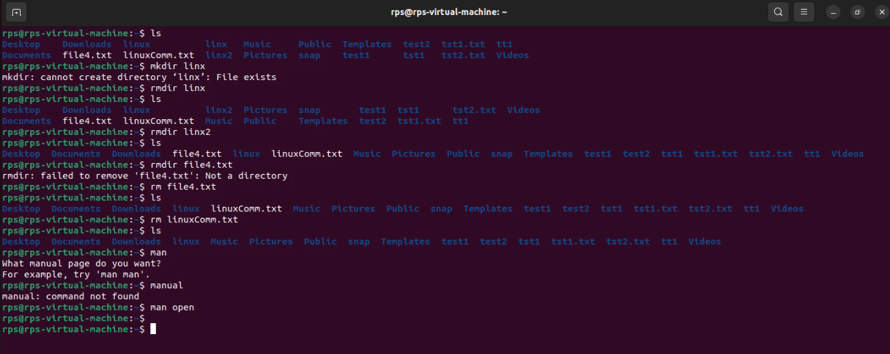

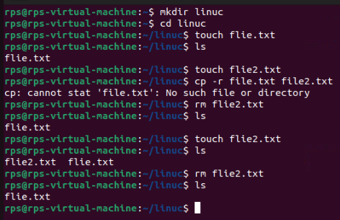

**Task 2 Exercise**

**Navigation :**

**1. cd (change directory): Moves you between directories.**

**Exercise: Navigate to your home directory (cd ~), then explore subdirectories like Documents (cd Documents). Use pwd (print working directory) to confirm your location. Try going back a directory with cd ...**

**pwd (print working directory): Shows your current directory path.**

**Exercise: After navigating using cd, use pwd to verify the path.**

**ls (list): Lists files and directories in the current directory.**

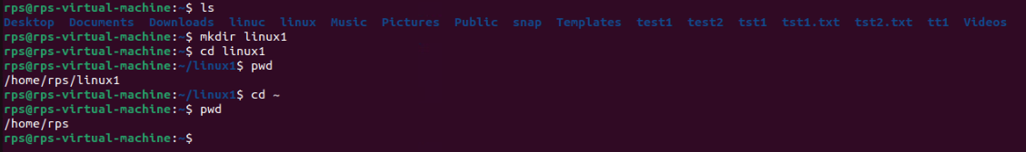

**2. Exercise: Use ls in your home directory and note the listed items. Try ls -l (long format) for detailed information like permissions, owner, and size.**

**File and Directory Management:**

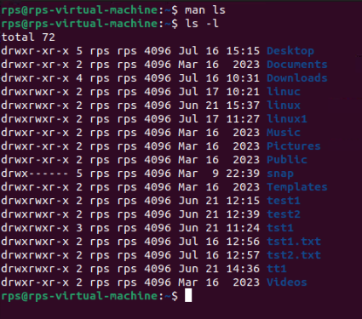

**3. mkdir (make directory): Creates a new directory.**

**Exercise: Create a new directory called "Projects" (mkdir Projects). Use ls to confirm its existence.**

**rmdir (remove directory): Deletes an empty directory.**

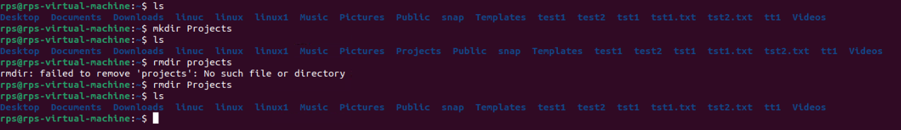

**4. Exercise: Make a directory named "temp" (mkdir temp). Delete it after verifying its existence with ls (rmdir temp).**

**touch (create file): Creates an empty file.**

**Exercise: Create a file called "test.txt" (touch test.txt). Use ls to see it listed.**

**cp (copy): Copies a file or directory to another location.**

**Exercise: Copy "test.txt" to your Documents directory (cp test.txt Documents). Verify the copy with ls Documents.**

**mv (move/rename): Moves or renames a file or directory.**

**Exercise: Rename "test.txt" to "data.txt" (mv test.txt data.txt). Use ls to confirm the change. You can also move files to a different directory (e.g., mv data.txt Documents).**

**rm (remove): Deletes files or directories (use with caution!).**

**Exercise: Important: Only use this after creating a test file (e.g., touch temp.txt). Delete "temp.txt" with rm temp.txt. Never use rm -rf without understanding the risks!**

**File Viewing and Permissions:**

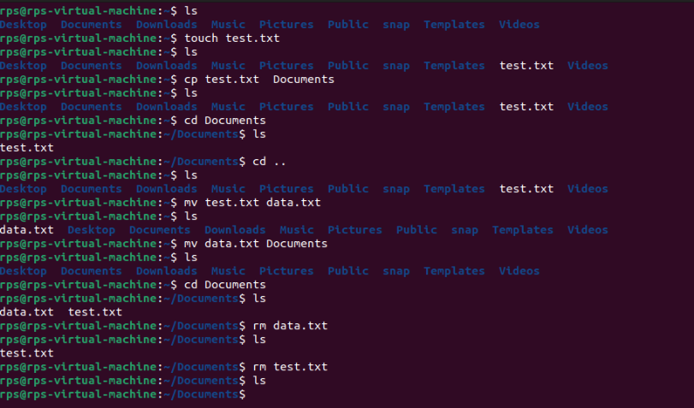

**5. cat (concatenate): Displays the contents of a text file.**

**Exercise: Create a text file named "message.txt" with some content (e.g., using a text editor). Then, use cat message.txt to view its contents.**

**more (pager): Displays a file's contents one screen at a time (useful for long files)**

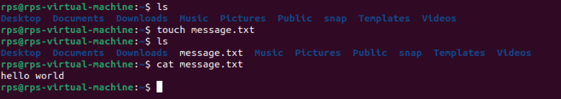

**6. Exercise: Create a larger text file (e.g., "long_text.txt") and use more long_text.txt to navigate through its content page by page.**

**less (pager): Similar to more, but allows you to move backward in the file.**

**Exercise: Use less with "long_text.txt" to try moving backward using the Up arrow key.**

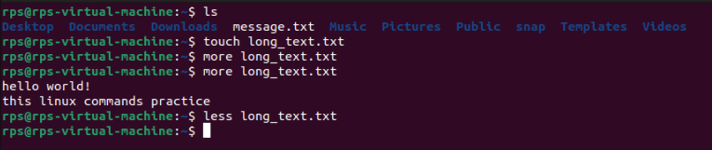

**7. chmod (change mode): Modifies file permissions (owner, group, others) for read, write, and execute access.**

**Capture7.PNG**

**8. Exercise: This requires understanding permissions. Refer to the man chmod page for details. Proceed with caution when modifying permissions.**

**Getting Help and Information:**

**man (manual): Provides detailed information about a command.**

**Exercise: Use man ls or man cd to learn more about these commands.**

**info (information): Another source of documentation for some commands, often more user-friendly than man.**

**Exercise: Try info ls or info cd if available on your system.**

**--help or -h (help flag): Provides a brief overview of a command's usage.**

**Exercise: Use ls --help or ls**

**-h to see the basic usage options for ls.**

**Capture8.PNG**

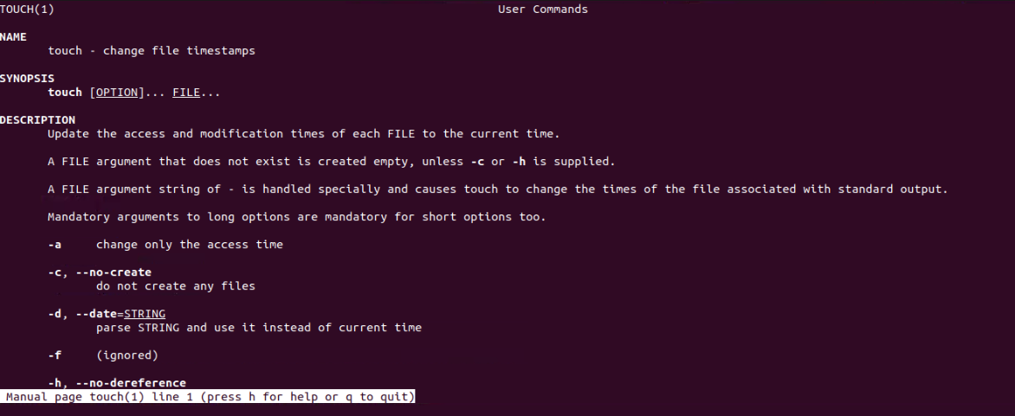

**ls –help :**

**Capture10.PNG**

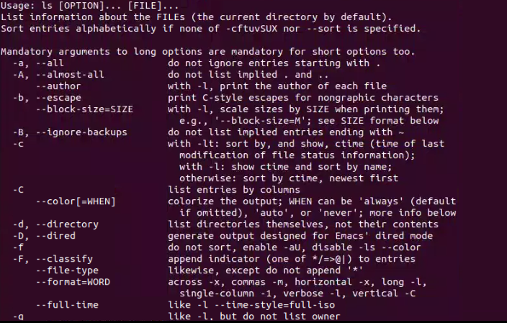

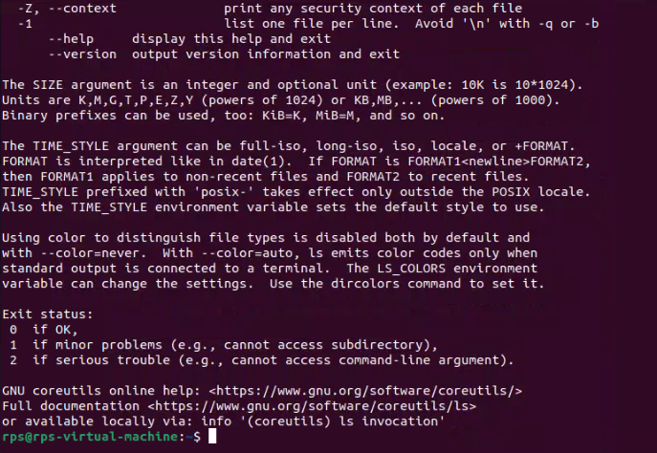

**Navigation and File Manipulation:**

**cd ~ && mkdir exercises && cd exercises: Navigate to your home directory, create a new directory named "exercises," and then move into it.**

**cp ../data.txt . (assuming "data.txt" exists in the parent directory): Copy a file named "data.txt" from the parent directory into your current "exercises" directory.**

**mv important_file.txt important_data.txt && touch report.md: Rename a file named "important_file.txt" to "important_data.txt" and create a new Markdown file named "report.md" within the "exercises" directory.**

**cat report.md (assuming the file is empty): View the contents (which should be empty) of the "report.md" file using cat.**

**echo "This is a report" >> report.md: Append a line of text "This is a report" to the "report.md" file using redirection ('>>').**

**less report.md: Use less to view the contents of the "report.md" file, which now contains the appended text.**

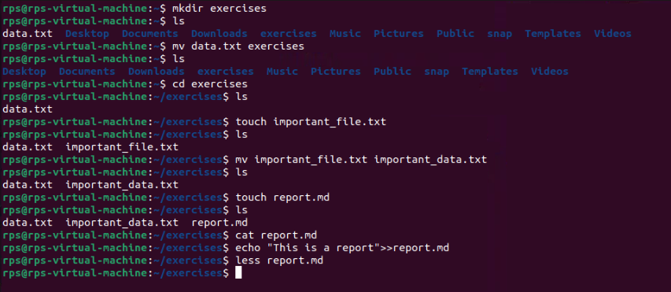

**Less view content**

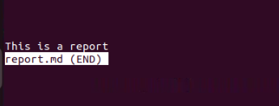

**Finding and Organizing Files:**

**ls -l | grep 'txt$': List all files in the current directory with the long format (-l) and filter the output using grep to only show files ending with the ".txt" extension.**

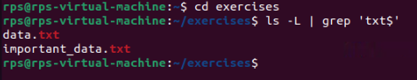

**find . -name 'data*': Search for all files starting with "data" (including "data.txt", "data_backup.csv", etc.) recursively within the current directory and its subdirectories using find.**

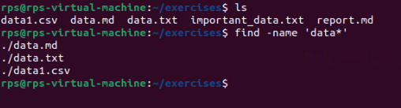

**mv data* data_archive/: Move all files starting with "data" into a new directory named "data_archive" (create it if it doesn't exist).**

